Sort and snap  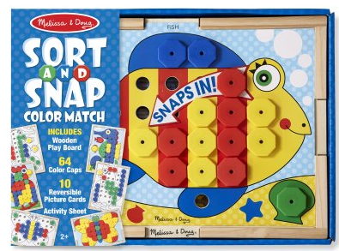  Basic Level  Ages: Pre-K-3rd grade | Pieces included in visuals  Rules for game  - Have the students select a board to complete together  - Taking turns, the student will request the color that they want from the other play partner  - Play game till the puzzle is complete  Additional Tips and Ideas  - For students that cannot color match, have them work together on the none color side  - Have students ask for the board and pieces at the beginning  - Practice your turn/ my turn

